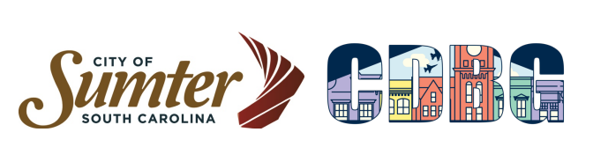
Executive Summary

Citizens were advised on May 7, 2025, via an advertisement in The Item that the Consolidated Annual Performance and Evaluation Report (CAPER) would be on display from May 21-June 21, 2025. Citizens are encouraged to come to review the plan and share their input as to how the City spent Community Development Block Grant (CDBG) funds during the last fiscal year (April 1, 2024-March 31, 2025).

Sewer Improvements (plumbing repairs) were completed for five (5) Low to Moderate Income (LMI) homeowners during this fiscal year.

Historic Preservation provides partnerships with businesses and property owners. The Façade Grant Program allots funds to repair the facades of buildings in the downtown business district. Since the inception of the current Façade Grant program (which started in 2002), over $13 million dollars of historic building renovations have been completed in the downtown historic district while spending less than $400,000 dollars of CDBG funds. During this CAPER period, façade grant assistance was provided for two (2) downtown businesses.

Housing Repairs were accomplished with funding from CDBG. A total of seven (7) owner-occupied homes were rehabilitated using CDBG funds for LMI occupants during the fiscal year of April 1, 2024, through March 31, 2025. Under the housing repair line item, the City used funds to pay inspectors for lead-based paintwork and the construction advisor for work write-ups, inspections, and bid preparation. Each unit is inspected prior to construction, and again after construction is completed for clearance of lead-based paint.

United Ministries Housing Repair Ten (10) owner-occupied houses had minor repairs done for LMI occupants.

Youth Employment benefited sixty-one (61) students last summer. Thirty-five (35) were for the Co-Op program (14–15-year-old kids) and twenty-six (26) were for the Youth Corps program (16 and up kids in High School).

YMCA Funding allowed sixteen (16) LMI youth to receive a variety of services provided by the YMCA.

HYPE funding allowed 115 students to go on a summer camp field trip to Neptune Water Park in Hartville, South Carolina and provided funding to purchase 115 back packs and school supplies for the upcoming school year.

The Demolition Program provided for the demolition of nine (9) structures.

