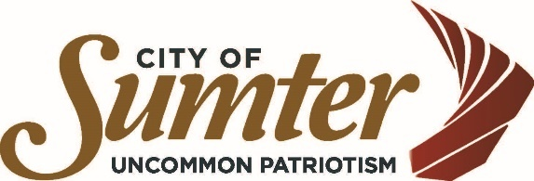

2024-2025 CDBG Budget

Community Development Department

Sumter, South Carolina 29150

HUD Allocation for period April 1, 2024 - March 31, 2025 $368,392.00
Public Service Cap (15%) $ 55,258.80
Administration Cap (20%) $ 73,678.40

Name of Project | Amount | Matrix Code | Regulation Citation | National Objective
Administration  (Administer the entitlement program) | $73,678 | 21A | 570.206 | ---
Historic Preservation  (Blight in commercial areas) | $10,000 | 16B | 570.202(D) | SBA
United Ministries  (Provide minor home repairs for LMI citizens) | $44,900 | 14A | 570.202 | LMH
Housing Repair  (Housing repair for LMI citizens) | $185,314 | 14A | 570.202 | LMH
YMCA Youth Services  (Provide vouchers for LMI youth to participate in activities) | $2,500 | 05D | 570.201 (E) | LMC*
Youth Employment  (Provide summer employment for 40 LMI youth) | $49,000 | 05D | 570.201 (E) | LMC*
HYPE Program  (Provide students supplies for LMI youth) | $3,000 | 05D | 570.201 (E) | LMC*
Total: $368,392.00

Public Service
LMI - Low-to-Moderate Income
LMA - Low-to-Moderate Area
LMC - Low-to-Moderate Clientele
LMH - Low-to-Moderate Housing
SBA - Slum/Blight Area
SBS - Slum/Blight Spot

